## Day 2 - Practice Session 1: Instructions for accessing Jupyter Notebooks

This document provides the instructions for accessing EGI hosted Jupyter notebooks for data-intensive analysis on cloud resources, provided by the EGI Federation.

## Access Jupyter

1. Enter the following URL in a browser: <https://envri-notebooks.fedcloud-tf.fedcloud.eu>
2. Start the authentication process by clicking on the “**Sign in with EGI Check-In**” button as shown in the figure below:



1. Select the **Identity Provider** you belong to from the discovery page:
   1. Browse through the list of Identity Providers to find your Home Organisation;

or, alternatively,

* 1. Type the name of your Home Organisation in the search box. Note that this filter only matches entries within the currently selected view (tab) of Identity Providers and is language-dependent (locale of your browser).

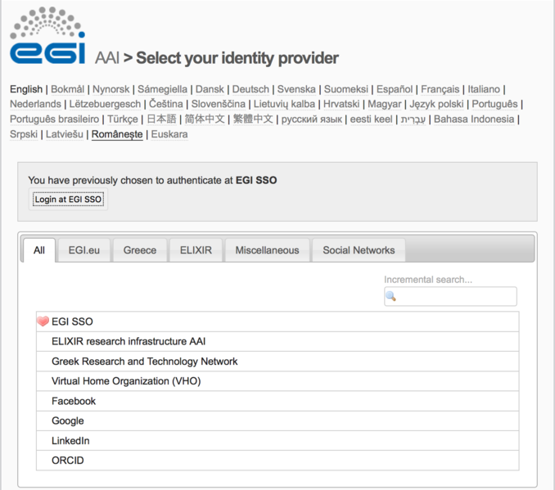

## Important:

In case the Identity Provider of your home institution is not in the list, or your home organisation does not yet support Federated authentication mechanisms, you can:

* Click on **“Social Networks”** (last tab) and use the identity provided by your account on one of the supported identity providers. Currently: ***Google***, ***Facebook*** and ***LinkedIn*** and ***ORCID*** are supported.
* **During the lab sessions, students are kindly invited to use their own ORCID iD accounts. To register for an ORCID iD, use the registration form:** [**https://orcid.org/register**](https://orcid.org/register)**.**

1. Following successful authentication you will see the control panel:

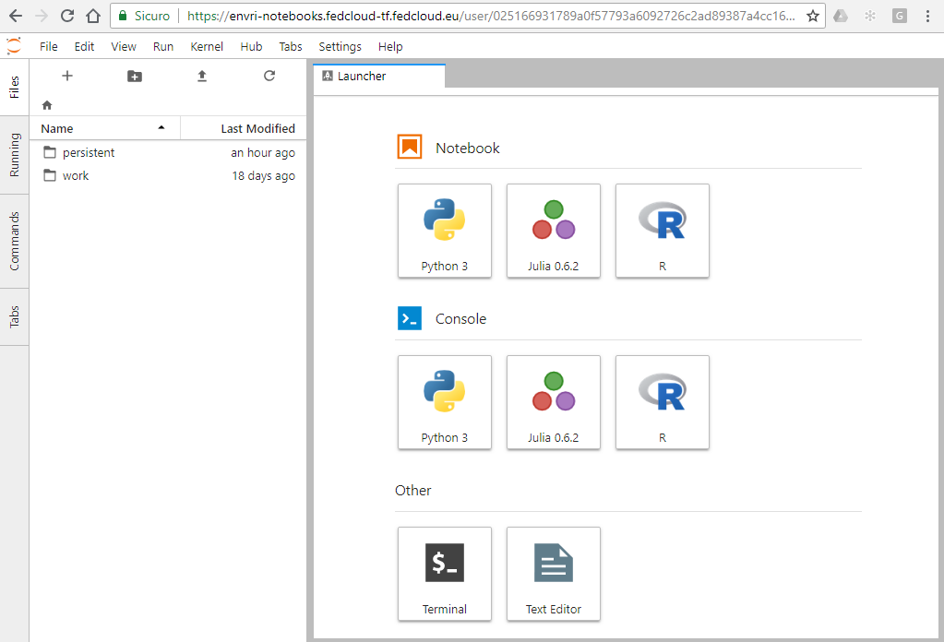

1. Launch your Notebook, with the desired Kernel, and start working with it.

## Contacts:

Should you have comments, please contact: giuseppe.larocca@egi.eu and enol.fernandez@egi.eu